**Assignment on ORACLE**

**Consider the following Schema Diagram for understanding the structure and relationship among entities of a library management system database and based on this diagram a database is created that will be shared with you. Now import the database and answer the following Queries.**

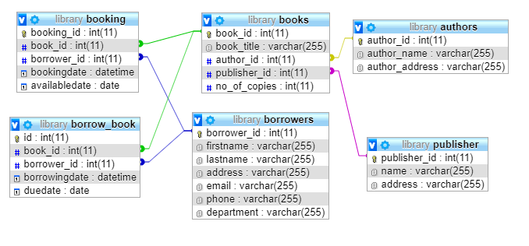

|  |  |
| --- | --- |
|  | **PART A** |
|  | **Create a database named *library* on ORACLE Database with the help of the given schema diagram and Insert at least 5 records for each of the table. Also implement the sequence with trigger for auto increment for each of the table.** |
|  | **PART B**  Answer the following query: |
| **1.** | Write a query to shows the details of a borrower. |
| **2.** | Write a query to find the book_title as Title, author_name as Author, publisher name of all the books available in the library. |
| **3.** | Write a query to find (book title) which books have been borrowed. [**hints**: distinct books from borrow_book] |
| **4.** | Write a query to find the details of a book which writer is Nazrul. |
| **5.** | Write a query to list authors whose name starts with M, S, R characters. |
| **6.** | SQL query to list the details of borrowers who have borrowed more books. |
| **7.** | SQL query to list the details of borrowers who have borrowed at least one book. |
| **8.** | Write a trigger (**your class roll and nick name: abc_001**) which reduces the number of available copies of books (from books table) when anyone borrowing a book (inserting borrow_book table). |
| **9.** | Create a procedure (**your nick name: abcd**) that will take book_id and provides the details of the book author. |
| **10.** | Create a function that takes borrower email and shows the number of days left to return the book. |
| **11.** | Create a view (**your class roll: CSE001**) that displays the borrower full name (firstanme and lastname), book name and borrowing date. |
| **12.** | First execute the following command:  CREATE TABLE writters(  writer_id INT NOT NULL AUTO_INCREMENT,  writer_name varchar(40),  writer_address varchar(40),  PRIMARY KEY(writer_id)  );  Now, Write an SQL statement insert rows to writters table from authors table. |
| **13.** | Write an SQL query to fetch three records of the table borrow_book. |
| **14** | Write an SQL query to fetch the last record of the table borrowers. |
|  | **PART C** |
|  | Write a program which will show a ***book_id*** (from table book) is prime or not using PL/SQL. |

**Submission Instructions**: Solve the assignment using SQL Developer on ORACLE database and submit the sql file titled by class roll (class roll like: 17CSE001.sql). A sample solution is given.

**Good Luck!!!**